1、After a factory reset, the device will erase all settings and data. You will see the following screen:
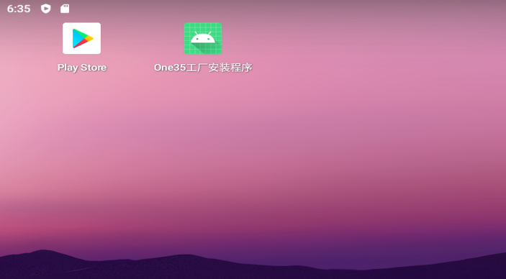
The application with the green icon is used for the factory installation of the Dawn frontend. It serves no purpose for your daily use and may be uninstalled.
- Transfer the Dawn frontend software to the device via MTP or SD card and install it. (You can find the software at https://github.com/Magicx-Breeze/One35/releases; installing the latest version is recommended.)
- Launch the Dawn app. You will see:
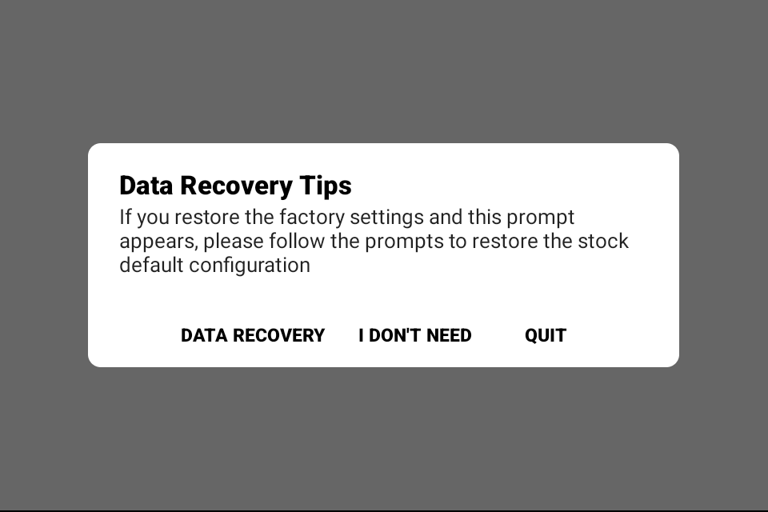
Please select DATA RECOVERY. This will complete all configurations and pre-install the stock software.
If you select I DONT NEED, please ensure you have advanced knowledge of emulator configuration, including the ability to manually set up key mappings for all emulators. This option is not recommended for beginners..
- After selecting DATA RECOVERY, you will see the following screen：
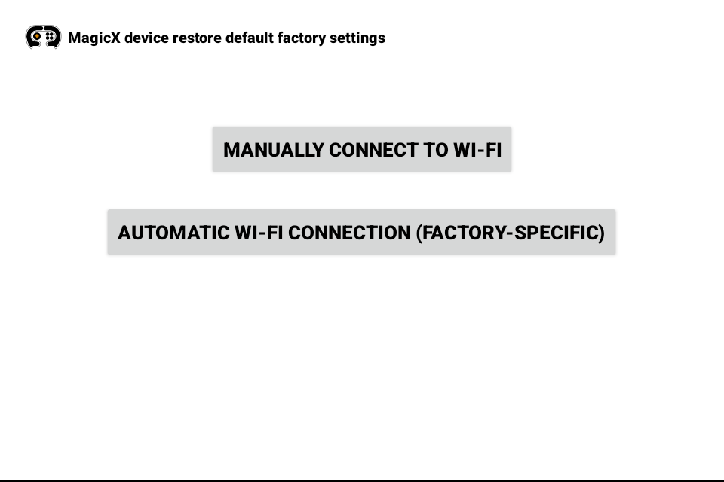
Please select MANUALLY CONNECT TO WI-FI to connect to your network. Do not select AUTOMATIC WI-FI CONNECTION (FACTORY-SPECIFIC); this is an automatic setting used strictly for our factory setup and serves no purpose for you.

- After setting up the network, you will see the following screen：
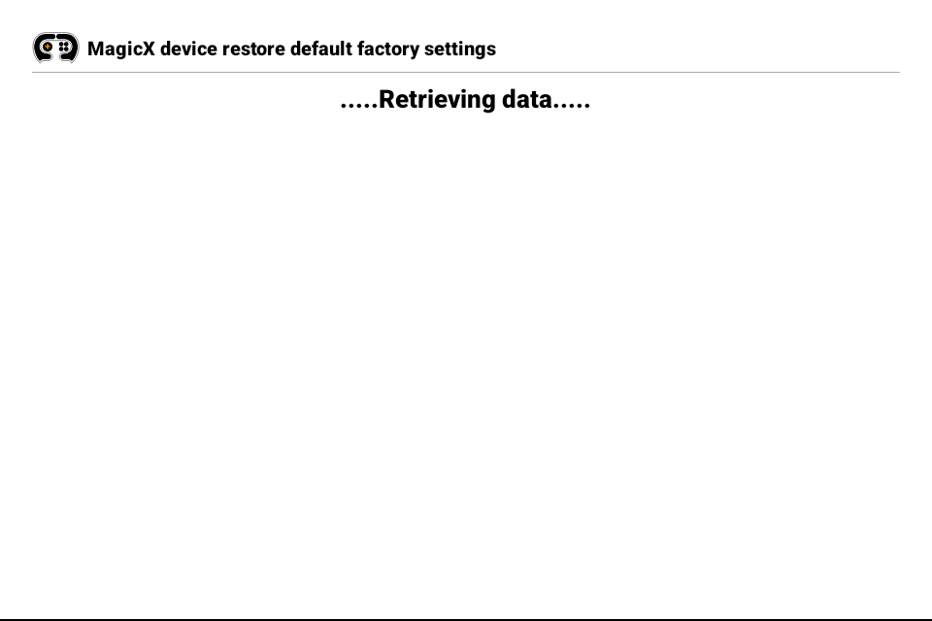
This will automatically pre-install and configure all emulators. Please simply wait and do not turn off your device during this process. It takes approximately 10 minutes.
- When the data recovery process is complete, you will see the following screen：
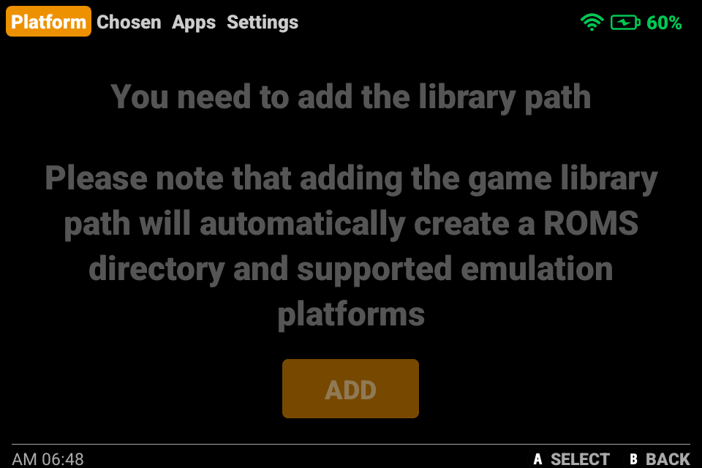
7、Use the L2/R2 buttons to navigate to the APPS section, then select and enter Azahar to configure the emulator file directories.
Note: If you skip this step, 3DS games will crash.
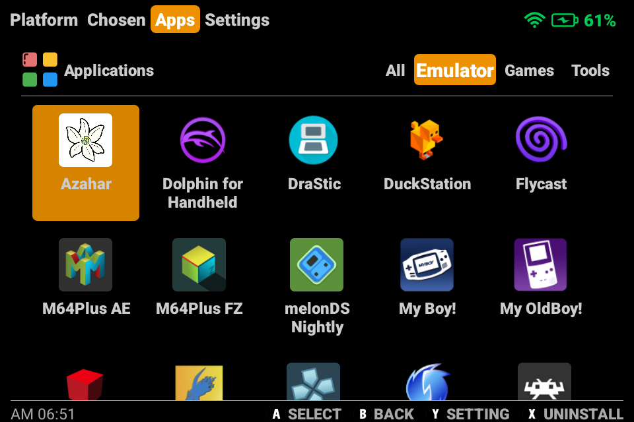

- Configure the Select User Folder in Azahar. Navigate to the following path: Internal Storage > MagicX One 35 > Config > Azahar.
Once inside the Azahar directory, select USE THIS FOLDER.
Below is the confirmation message shown after a successful setup:：
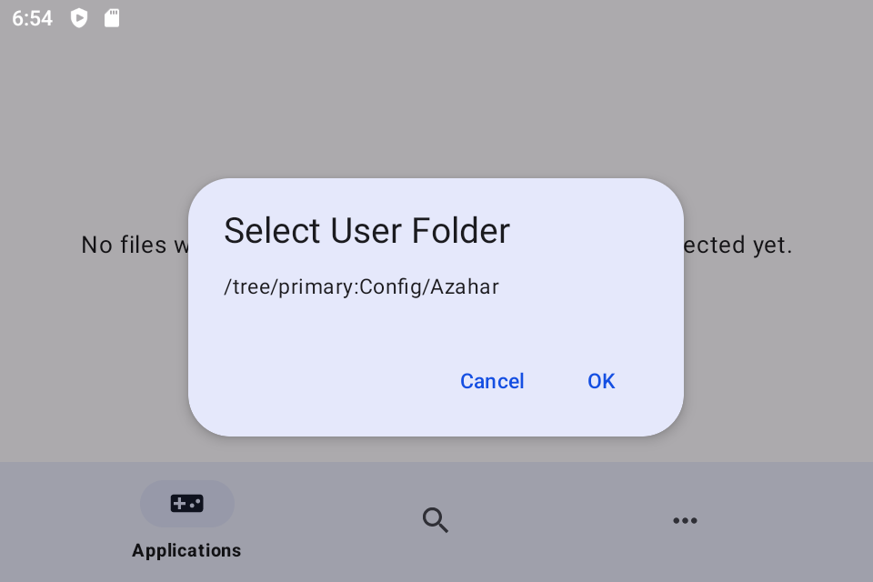
- Return to the Dawn frontend and use the L2/R2 buttons to navigate to the Platforms section.
Select ADD to configure the internal storage ROMs path.
Navigate to the specific path: MagicX One 35 > game.
Once inside the 'game' directory, select USE THIS FOLDER.
Follow the prompts to refresh Dawn. Your device is now restored to its stock state.
